homework three

Yi (Chris) Chen

October 8, 2017

## homework three

### problem 2.23

# problem a  
setwd("C:/Users/cheny/Desktop/study/linear regression model/homework/homework three")  
data_23 <- read.table('19.txt',header = FALSE,col.names=c('GPA','ATC'))  
reg_23 <- lm(data_23$GPA ~ data_23$ATC)  
anova_23 <- anova(reg_23)  
anova_23

## Analysis of Variance Table  
##   
## Response: data_23$GPA  
## Df Sum Sq Mean Sq F value Pr(>F)   
## data_23$ATC 1 3.588 3.5878 9.2402 0.002917 **  
## Residuals 118 45.818 0.3883   
## ---  
## Signif. codes: 0 '***' 0.001 '**' 0.01 '*' 0.05 '.' 0.1 ' ' 1

# problem c  
f_value <- qf(0.99,1,118)  
anova_23$`F value` > f_value

## [1] TRUE NA

t_value <- qt(1-0.01/2,118)  
t_value_star <- 3.040  
t_value_star > t_value

## [1] TRUE

cat('conclude Ho')

## conclude Ho

# problem d   
sse <- 45.818  
ssr <- 3.588  
ssto <- 3.588 + 45.818  
r2 <- ssr/ssto  
cat('the relative reduction is', r2)

## the relative reduction is 0.07262276

# problem e  
r <- sqrt(r2)  
cat('the r is',r)

## the r is 0.2694861

### problem 2.26

# problem a  
data_26 <- read.table('1.22.txt',header = FALSE, col.names = c('hardness','time'))  
reg_26 <- lm(data_26$hardness ~ data_26$time)  
anova_26 <- anova(reg_26)  
anova_26

## Analysis of Variance Table  
##   
## Response: data_26$hardness  
## Df Sum Sq Mean Sq F value Pr(>F)   
## data_26$time 1 5297.5 5297.5 506.51 2.159e-12 ***  
## Residuals 14 146.4 10.5   
## ---  
## Signif. codes: 0 '***' 0.001 '**' 0.01 '*' 0.05 '.' 0.1 ' ' 1

# problem b  
f_value <- qf(0.99,1,13)  
anova_26$`F value` > f_value

## [1] TRUE NA

t_value <- qt(1-0.01/2,13)  
t_value_star <- 22.51  
t_value_star > t_value

## [1] TRUE

cat('conclude Ho')

## conclude Ho

# problem c  
y_hat <- data_26$time * reg_26$coefficients[2] + reg_26$coefficients[1]  
deviation_of_error <- data_26$hardness - y_hat  
y_mean <- mean(data_26$time)  
deviation_of_regression <- y_hat - y_mean  
  
par(mfrow = c(1,2))  
plot(deviation_of_error~data_26$time,ylim=c(-10,250))  
plot(deviation_of_regression~data_26$time,ylim=c(-10,250))

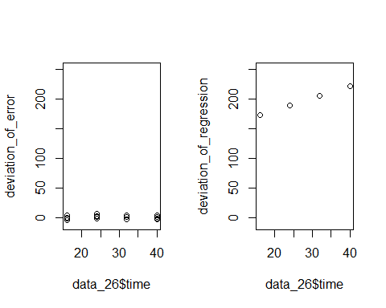

### problem 2.66

# problem a  
set.seed(1)  
residules <- rnorm(n = 5, mean = 0, sd = 5)  
x <- c(4,8,12,16,20)  
y <- x * 4 + 20 + residules  
reg_66 <- lm(y~x)  
plot(y~x)  
abline(reg_66)

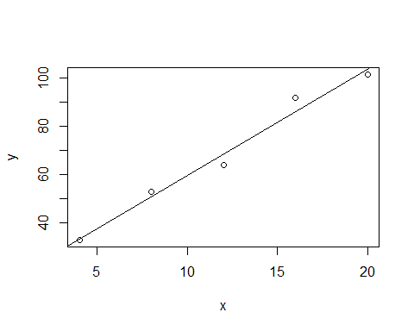

y_h <- reg_66$coefficients[1] + 10 * reg_66$coefficients[2]  
cat('y_h is', y_h)

## y_h is 59.81546

confidenc_interval_up <- y_h + qt(1-0.05/2,5-2)*sqrt(sum(reg_66$residuals^2)*(1/5+(10-mean(x))/sum((x-mean(x))^2)))  
confidenc_interval_down <- y_h - qt(1-0.05/2,5-2)*sqrt(sum(reg_66$residuals^2)*(1/5+(10-mean(x))/sum((x-mean(x))^2)))  
  
# problem b and c  
b1 <- vector()  
for(i in 1:200){  
 residules <- rnorm(n = 5, mean = 0, sd = 5)  
 x <- c(4,8,12,16,20)  
 y <- x * 4 + 20 + residules  
 reg_66 <- lm(y~x)  
 b1 <- c(b1,reg_66$coefficients[2])  
}  
mean(b1)

## [1] 3.999999

sd(b1)

## [1] 0.4397091

hist(b1)

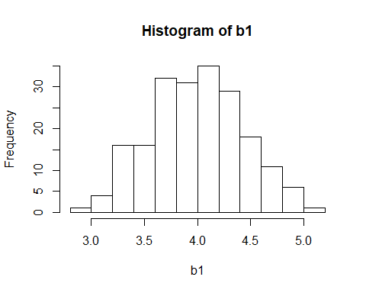

#problem d  
y_true <- 4 * 10 + 20  
times <- vector()  
for(i in 1:200){  
 residules <- rnorm(n = 5, mean = 0, sd = 5)  
 x <- c(4,8,12,16,20)  
 y <- x * 4 + 20 + residules  
 reg_66 <- lm(y ~ x)  
 y_h <- reg_66$coefficients[1] + 10 * reg_66$coefficients[2]  
 confidenc_interval_up <- y_h + qt(1-0.05/2,5-2)*sqrt(sum(reg_66$residuals^2)*(1/5+(10-mean(x))/sum((x-mean(x))^2)))  
 confidenc_interval_down <- y_h - qt(1-0.05/2,5-2)*sqrt(sum(reg_66$residuals^2)*(1/5+(10-mean(x))/sum((x-mean(x))^2)))  
  
 if( y_true <= confidenc_interval_up & y_true >= confidenc_interval_down){  
 times <- c(times,1)  
 }else{  
 times <- c(times,0)  
 }  
}  
propotion <- sum(times)/length(times)

### problem 2.68

data_68 <- read.table('1.20.txt',header = FALSE, col.names = c('# of mins','# of copiers'))  
reg_68 <- lm(data_68$X..of.mins ~ data_68$X..of.copiers)  
y_h <- data_68$X..of.copiers * reg_68$coefficients[2] + reg_68$coefficients[1]  
up_band <- y_h + sqrt(2*qf(0.9,2,45-2))*sqrt(sum(reg_68$residuals^2)/43)*sqrt(1/45 + (data_68$X..of.copiers-mean(data_68$X..of.copiers)^2)/(sum(data_68$X..of.copiers-mean(data_68$X..of.copiers)^2)))  
down_band <- y_h - sqrt(2*qf(0.9,2,45-2))*sqrt(sum(reg_68$residuals^2)/43)*sqrt(1/45 + (data_68$X..of.copiers-mean(data_68$X..of.copiers)^2)/(sum(data_68$X..of.copiers-mean(data_68$X..of.copiers)^2)))  
  
plot(data_68$X..of.mins~data_68$X..of.copiers,xlim=c(1,8))  
abline(reg_68)  
points(up_band~data_68$X..of.copiers,type='l')  
points(down_band~data_68$X..of.copiers,type='l')  
  
# or it can be solved in this way  
library(ggplot2)

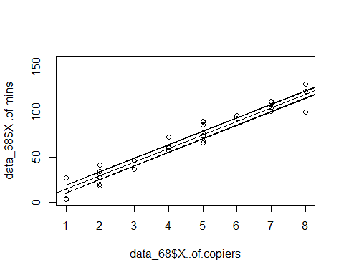

result <- ggplot(data_68,aes(x=data_68$X..of.copiers,y=data_68$X..of.mins))+geom_point() + stat_smooth(method = lm)  
plot(result)

